**Project:**

Sheng Dictionary

**Description:**

This project is intended to demonstrate how a person can create a dictionary by giving the original word and its meaning.

The project is done using Python as the programming language and Text file.

**Installation:**

You will require Python installed in the computer and have a text editor.

For the text file, please change the location of the file to point to your own computer environment.

**How to Use This Project:**

Once you have the environment set, you just run the program. It will display the menus on the screen.

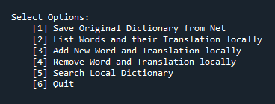

Press 1 to save original word dictionary from the net.

Press 2 to show the words disctionary as is saved in the local storage location

Press 3 to add new words to your dictionary. If the word exists, it will just display the current meaning retrieved from the database and will not save new.

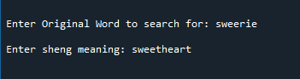

Press 4 to delete dictionary words

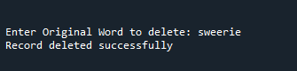

Press 5 to search a dictionary word

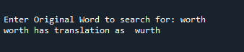

**Author:**

Nicholas Okello